**שם קורס :מבוא לבסיסי נתונים**

**עבודה בנושא שאילתות SQL**

**שם מרצה : ילנה קליימן**

**מגיש: איתי גוטליב**

**1**

**SELECT B.passenger_id**

**FROM Flights AS F, Bookings AS B**

**WHERE F.flight_id=B.flight_id and F.destination_city='Washington' and F.source_city='San Francisco';**

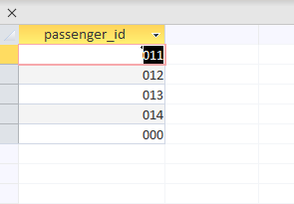

**2**

**SELECT DISTINCT F1.source_city**

**FROM Flights AS F1, Flights AS F2**

**WHERE F1.source_city=F2.source_city and F2.destination_city='Newark' and F1.destination_city='Honolulu';**

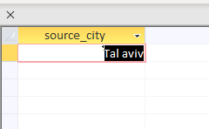

**3**

**SELECT D.flight_id, D.date**

**FROM Departures AS D**

**WHERE ((not exists (Select D.flight_id,D.date**

**From Bookings B**

**;((( where D.flight_id=B.flight_id and D.date=B.date**

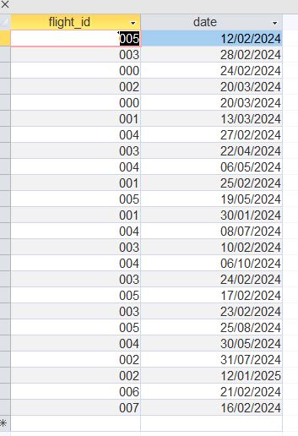

**4**

**SELECT Flights.source_city, Count(Flights.destination_city) AS Count_Destination**

**FROM Flights**

**GROUP BY Flights.source_city**

**HAVING (((Count(destination_city))>2))**

**ORDER BY Count(Flights.destination_city) DESC;**

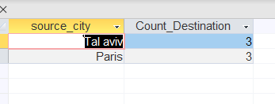

**5**

**SELECT passenger_id, date**

**FROM Bookings**

**GROUP BY passenger_id, date**

**HAVING COUNT(date) >= ALL (Select COUNT(date) From Bookings**

**;( group by passenger_id,date**



**6**

**SELECT DISTINCT B1.flight_id, B1.date, B1.departs, B1.seat_number**

**FROM Bookings AS B1, Bookings AS B2**

**WHERE B1.passenger_id<>B2.passenger_id and B1.flight_id=B2.flight_id and B1.date=B2.date and B1.departs=B2.departs and B1.arrives=B2.arrives and B1.seat_number=B2.seat_number;**

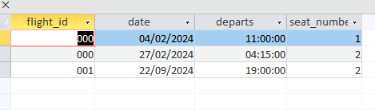

**7**

**SELECT Bookings.flight_id, Count(Bookings.passenger_id) as count_Passenger**

**FROM Bookings**

**GROUP BY Bookings.flight_id**

**HAVING (((Count(Bookings.[passenger_id]))>=All (select count(passenger_id)**

**From Bookings**

**group by(flight_id))));**

**הנחה – אם נוסע לקח x פעמים את הטיסה y אז ב-y יהיו x נוסעים יותר**

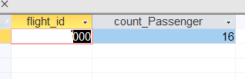

**8**

**SELECT P.pilot_name**

**FROM Pilots AS P**

**WHERE P.salary/12 < (Select min(price)**

**from Flights F**

**Where F.source_city="Paris" and F.destination_city="Madrid");**

